Blue Mansion many years ago
There were times when I had to walk to secondary school at Convent Light Street. I would take Northam Road, then walked along Farquhar Street, crossed Penang Road and walked all the way passing St Xavier’s school. Here I would cross the road and my school was just around the corner.
Just after crossing Penang Road, I passed by a large bungalow on my right. This house was below the road level, so you could see what was going on in it. There were lots of flowers, vegetables and fruits planted and there were people taking care of these plants. After taking a thorough look at this beautiful scenery, I would take a slow walk towards my school. I wanted to know the secret behind this mansion but little did I know that much later I would meet someone who used to stay there in her childhood. Facebook has connected me to so many schoolmates and one of them is Elvenar Lai.
On one of my trips to Penang in March, I met up with Elvenar Lai who used to stay in this bungalow when it was called “the old house”. This mansion was owned by Cheong Fatt Tze or Tjong Tjen Hsoen from 1840 to 1916. It is recorded that he died in Indonesia but was buried in China. We are not sure who lived in this mansion from 1917 to 1962 but Elvenar recalls of her stay here from 1963 to 1985. The eighth mistress (7th mistress’ son’s wife) being the 3rd generation of Cheong Fatt Tze lived in this bungalow. She had 2 sons and the other siblings (1 in Hong Kong and 1 in Singapore now) stayed on here.
I and my brother had the chance to have coffee at this mansion with Elvenar and her son and she talked non-stop of her adventure living at this mansion. The place is developed now due to commercialization and is a boutique hotel with a luxury look. Let me take you for a inside tour of this place when Elvenar lived here with her family.
Elvenar and more than 10 families rented the smaller rooms at less than RM40 per month. Later, the rent was increased to RM80 per month. Some tenants had no jobs. The owner’s son stayed in the bigger rooms. There was a row of 4 or 5 bucket toilets behind the house near the carriage and horse barn. The kitchen was located at the servants’ quarters and another kitchen at the east and west of the house. These families had 1 large room each where they studied, played, ate and slept. When they were bored, they would go to the main house and played around the front portion. They would play ‘kali tui’, badminton, flew kites, spun tops and just chasing each other. Sometimes they caught dragonflies at lily pond. They were not allowed to play with the towkay’s children in case they got hurt. Money is the main barrier between humans, be it at that time or at currently. The rich cannot play with the poor, they cannot fall in love with this group and what more marry someone from them. If someone went against this norm, they would be struck from the inheritance and shunned away from the family. Today, some things have changed but that is how the society views these things.

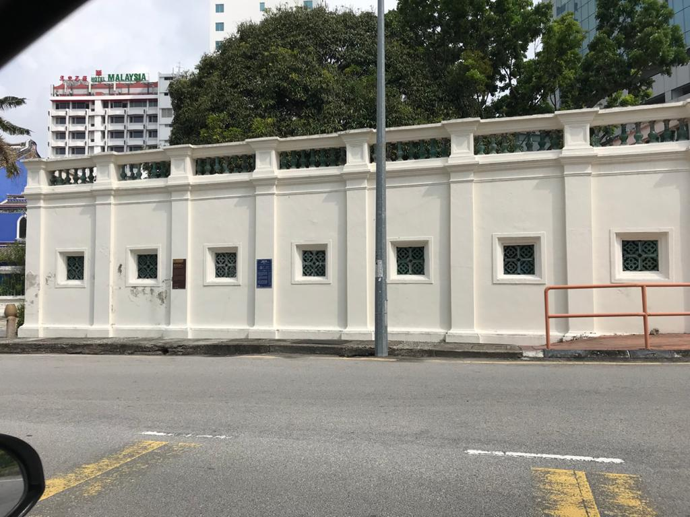
Front right 2nd window- bucket system. Elvenar’s 2nd Aunt and uncle’s room. Granny room. Her 2nd aunt Eldest aunt son’s room. Ah cheong Meng Soh room. LEONG family’s room, they had 6 children. Ah cheong meng Soh family moved out then the Lay family took the room.
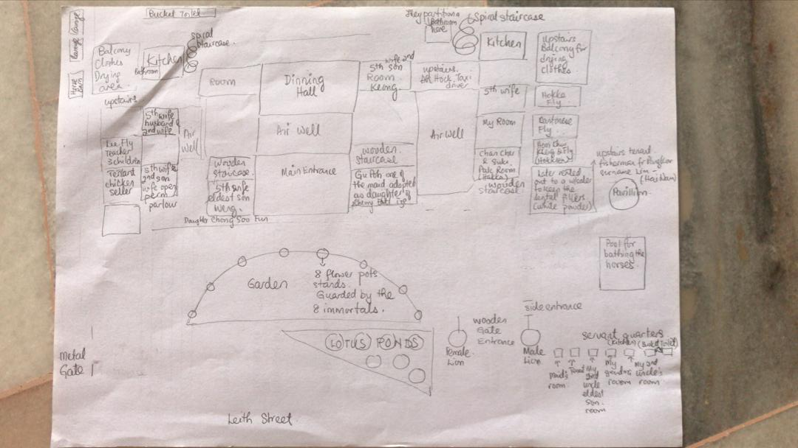
This is the layout of the mansion during Elvenar’s time there.

There were maids and they stayed at their quarters directly across the road and 1 maid was adopted as a daughter by the towkay. If the maid had a same surname, she was employed as a relative. The owners did not work but collected rent from their tenants and this was their source of income.
Elvenar’s grandmother used to keep charcoal and wood near the bucket toilet area. The bucket guy would come when it was dark to collect the nightsoil. His face was covered with a cloth and he had a big hat on his head. Back then, people looked down on the bucket guy as it was considered a very low-class job, another form of societal judgement. Luckily, Alam Flora has taken over this job and we do not see the bucket guys anymore. Everything goes into pipes and finally make it to the large septic tanks. People do not want to purchase property next to this tank for fear of the bad smell….. Well, back to my story; wood was used back then to make fire for cooking and a piece of burning firewood was used to chase away the mosquitoes while doing the big business. Elvenar remembers bringing cockroaches to school for our science project. Ah Chan Cher (sister) who was her neighbour worked at the bakery in Cold Storage just behind this mansion.

At the rear of this mansion, chicken and duck barn was placed at the entrance. From the chickens, they got their eggs and if there were extras, her mum would barter it for vegetables and other essentials at the Chowrasta market on Penang Road. There were rabbits, guinea pigs, dogs, cats and a pig too. Life was so much fun!
Near the chicken barn, there was a lemon tree but the lemons never turned yellow. There was also a jasmine tree always blooming due to the manure from the chickens and ducks. Elvenar picked the jasmine flowers to be offered to Buddha.
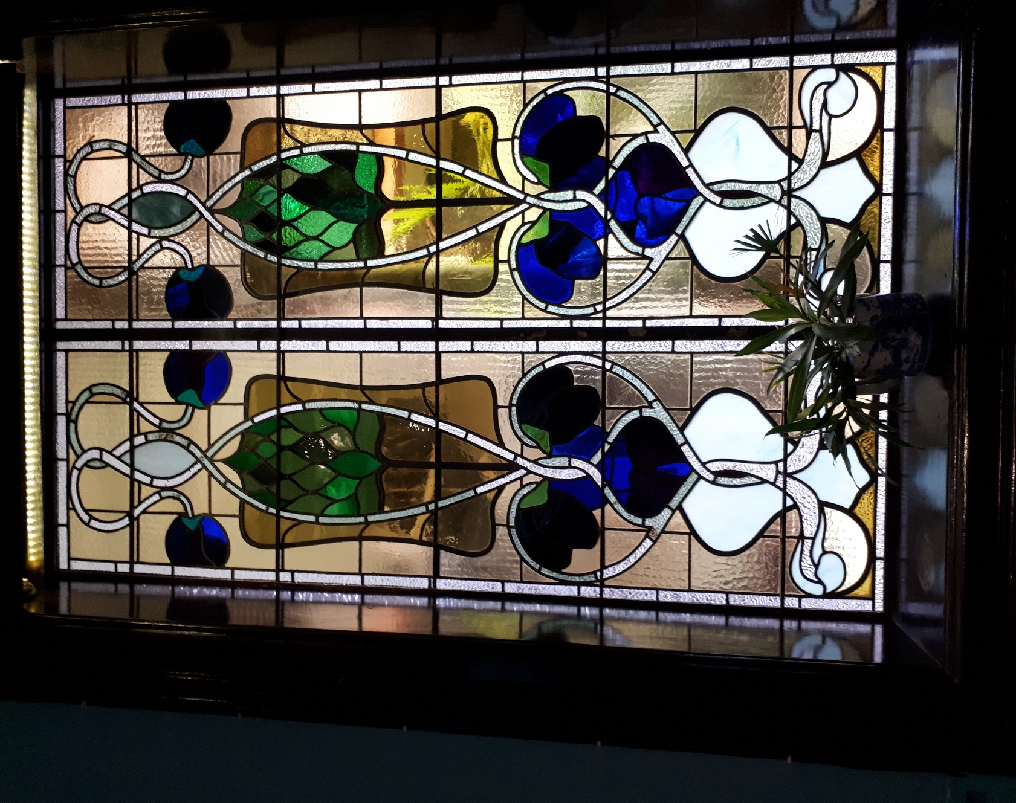
The window inside the mansion with beautiful architecture

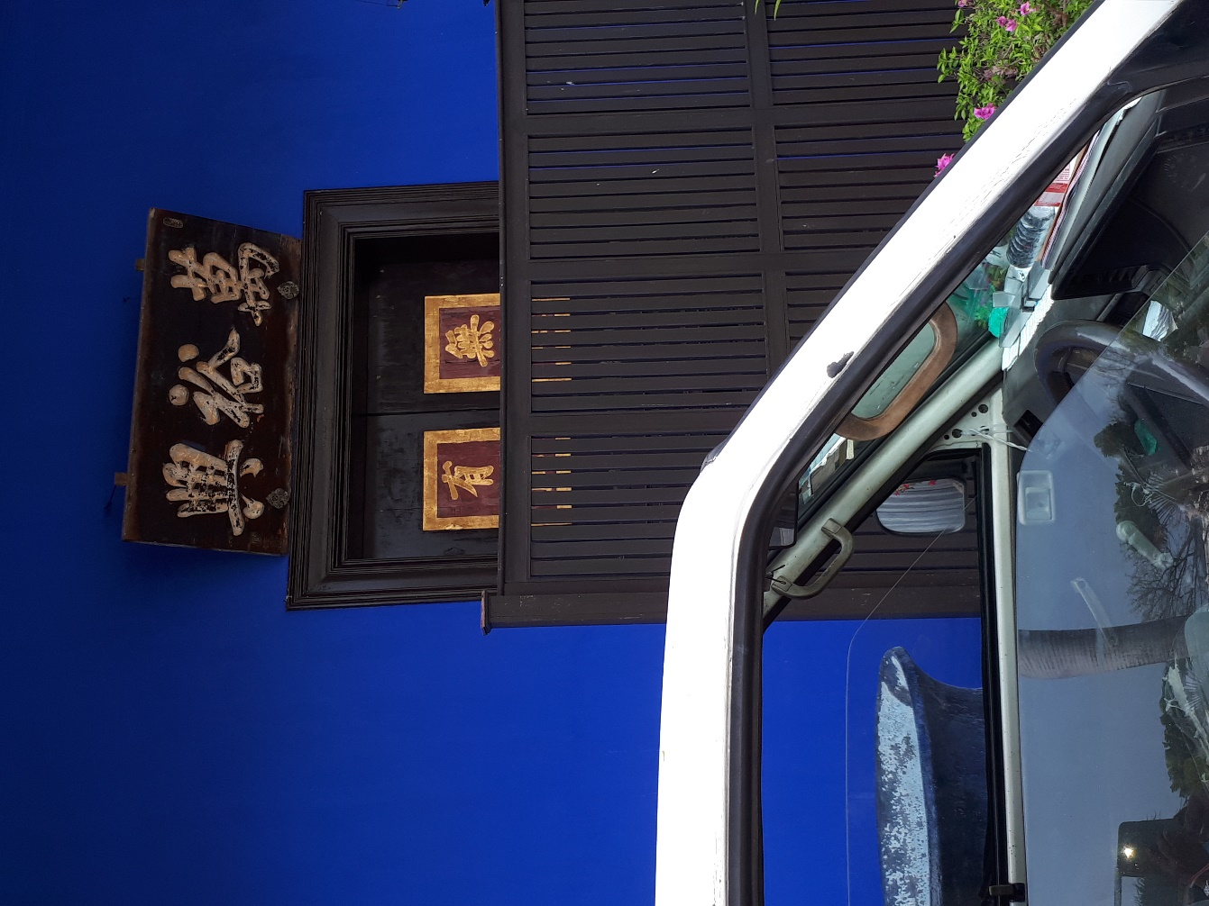
The side entrance to the mansion

